Acton Badminton Club kit order form |  |  |  | Customer Details  -Name:  -Contact number:  -E-mail:  -Delivery address:  Please send your completed order forms to: leeqxian@gmail.com
Item Name | Front | Back | Sizes |  | Price | Quantity and Size requested | Printing on back (included)
Teamline Tee | 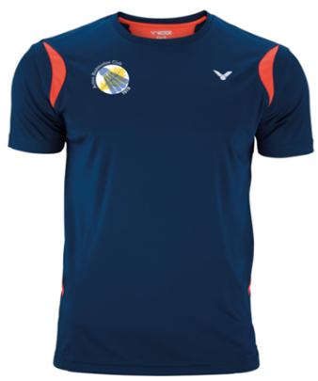 | 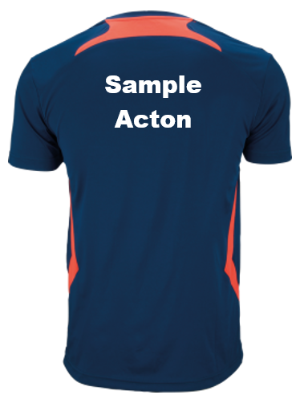 | XS - 3XL |  | £24.00
Teamline Polo | 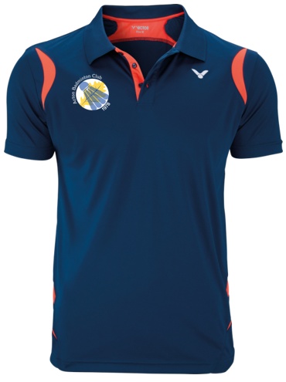 |  | UNISEX [ XS - 3XL]  FEMALE [ 34-42] |  | £29.99
Teamnline Jacket | 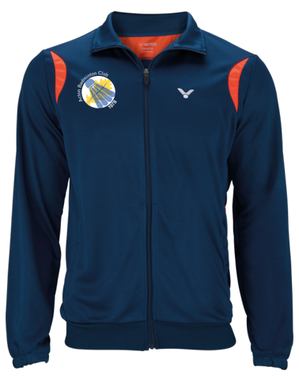 | 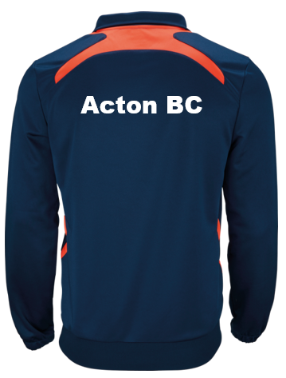 | S - XXL |  | £35.00
Teamline Pants | 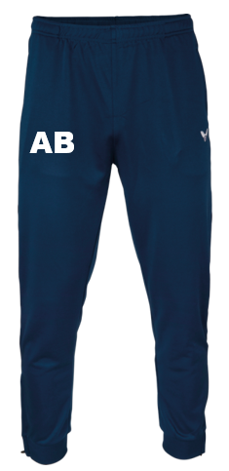 | 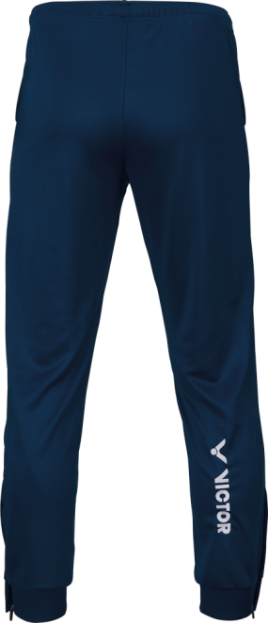 | S - XXL |  | £28.00
Teamline Hoody | 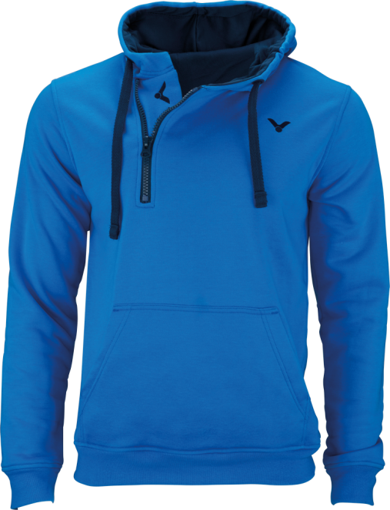 | 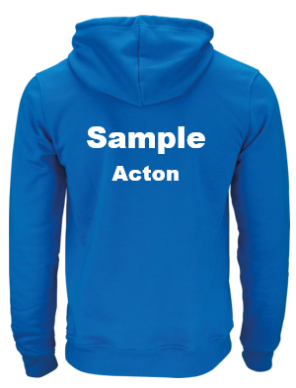 | XXS - XXL |  | £32.00
Longsleeve Melange | 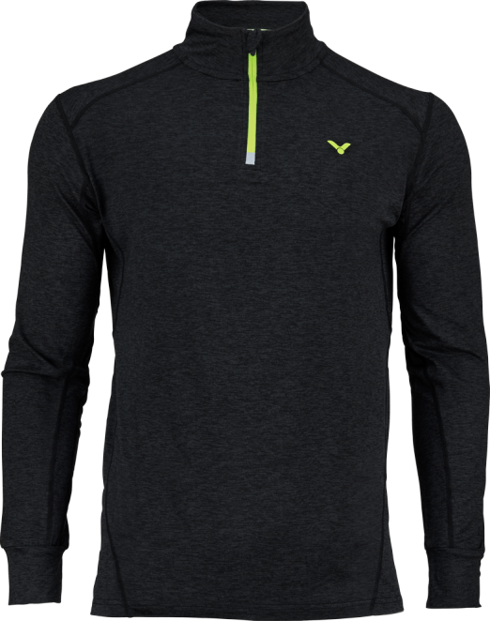 | 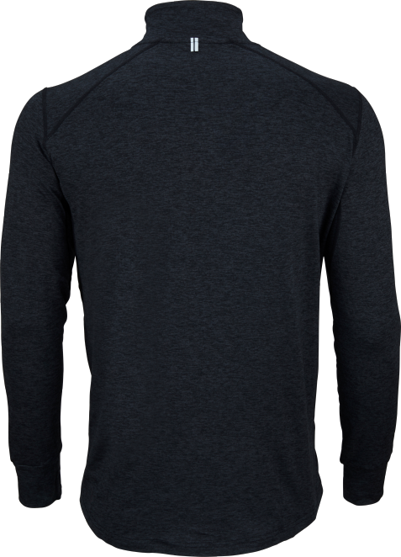 | XS - XXL |  | £28.00
Longsleeve (pink) | 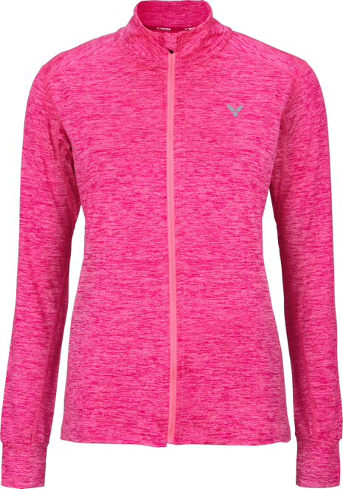 | 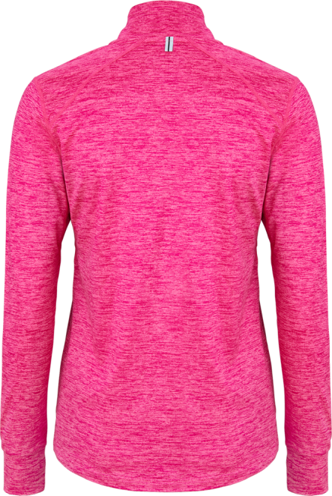 | 34-42 |  | £28.00
Shorts | 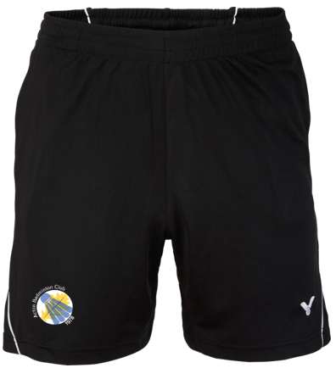 |  | XXS - XXL |  | £25.00
Skirt | 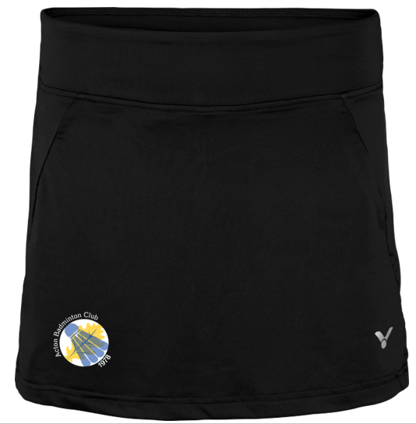 |  | 34-42 |  | £25.00

